**NAME – KARAN DAS**

**USER ID – 34763**

**MAIL-** [**karannnx20@gmail.com**](mailto:karannnx20@gmail.com)

**Topic Assignment:**

1. End-to-End Application Packaging.

2. Windows 10 vs Windows 11 (for App Packaging ).

3. Difference between User, Admin, and System Context.

4. Handling Scheduled Tasks and Use Cases.

**Practice activity:**

**1. End-to-End Application Packaging:**

It is the process of creating software so it can be deployed smoothly across many systems with minimal errors or manual works .

Process steps:-

* Gather Information about the software.
* Study the collected information and plan how to package the software in the best way.
* Create the package version of the application which meets the business requirements.
* After successfully create we testing the application that the application works properly or not .

There are two types of testing :- 1. QA ( Quality assurance ) And 2. UAT ( User acceptance testing )

* If all things are okay then it deploy in all systems where its needed.

Benefits:

* Consistency
* Easier updates
* Better control
* Mitigates security risks
* Decrease risk for business disruption
* Its helps to reduce support cost

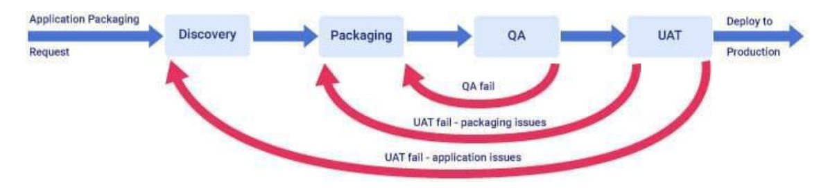

**2. Windows 10 vs Windows 11 (for App Packaging):**

Windows 10 benefits:

* Familiar interface
* Wide compatibility
* Stability
* Cost effective

Windows 11 benefits:

* New updated interface
* Strong security
* Better performance
* New Microsoft store
* Improved multi-tasking
* Enhanced gaming experience
* Optimized update process

**3. Difference between User, Admin, and System Context:-**

User Context: login user access, can run apps and do basic tasks.

System Context: Fully system access , it can access all files and install all things .

Admin Context: admin give permission then its also can access those things , can install software and change settings by admin permission .

**4.Handling Scheduled Tasks and Use Cases.**

Scheduled Tasks help run programs or scripts automatically at a set time or event.

Use Cases:

* Run cleanup scripts daily
* Launch apps at login
* Run updates or backups at night
* Run one-time scripts after deployment

We can create, edit, or delete tasks using Task Scheduler.